**The JBI Levels of Evidence are:**

The New JBI Levels of Evidence and Grades of Recommendation are now being used for all JBI documents as of the 1st of March 2014.

|  |  |
| --- | --- |
| Levels of Evidence - Effectiveness | |
| Level 1 – Experimental Designs | Level 1.a – Systematic review of Randomized Controlled Trials (RCTs) |
| Level 1.b – Systematic review of RCTs and other study designs |
| Level 1.c – RCT |
| Level 1.d – Pseudo-RCTs |
| Level 2 – Quasi-experimental Designs |  |
| Level 2.a – Systematic review of quasi-experimental studies |
| Level 2.b – Systematic review of quasi-experimental and other lower study designs |
| Level 2.c – Quasi-experimental prospectively controlled study |
| Level 2.d – Pre-test – post-test or historic/retrospective control group study |
| Level 3 – Observational – Analytic Designs |  |
| Level 3.a – Systematic review of comparable cohort studies |
| Level 3.b – Systematic review of comparable cohort and other lower study designs |
| Level 3.c – Cohort study with control group |
| Level 3.d – Case – controlled study |
| Level 3.e – Observational study without a control group |
| Level 4 – Observational – Descriptive Studies |  |
| Level 4.a – Systematic review of descriptive studies |
| Level 4.b – Cross-sectional study |
| Level 4.c – Case series |
| Level 4.d – Case study |
| Level 5 – Expert Opinion and Bench Research |  |
| Level 5.a – Systematic review of expert opinion |
| Level 5.b – Expert consensus |
| Level 5.c – Bench research/ single expert opinion |

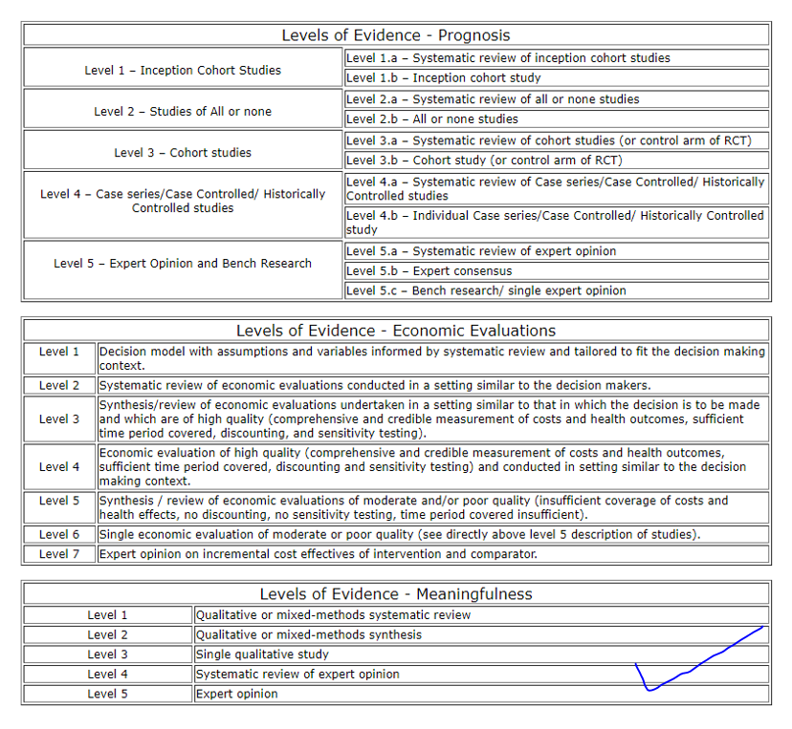

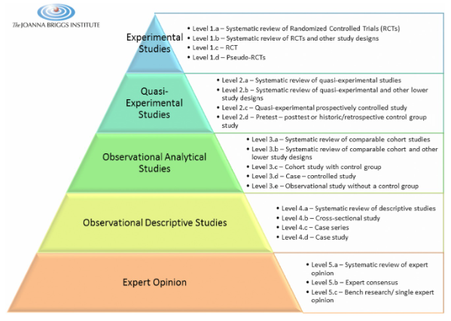

The Joanna Briggs institute levels of evidence for effectiveness

(The Joanna Briggs institute, [2014](https://sigmapubs.onlinelibrary.wiley.com/doi/10.1111/wvn.12094#wvn12094-bib-0025))