The JBI Levels of Evidence are:
The New JBI Levels of Evidence and Grades of Recommendation are now being used for all JBI documents as of the 1st of March 2014.
Levels of Evidence - Effectiveness
Level 1 – Experimental Designs | Level 1.a – Systematic review of Randomized Controlled Trials (RCTs)
Level 1 – Experimental Designs | Level 1.b – Systematic review of RCTs and other study designs
Level 1 – Experimental Designs | Level 1.c – RCT
Level 1 – Experimental Designs | Level 1.d – Pseudo-RCTs
Level 2 – Quasi-experimental Designs
Level 2 – Quasi-experimental Designs | Level 2.a – Systematic review of quasi-experimental studies
Level 2 – Quasi-experimental Designs | Level 2.b – Systematic review of quasi-experimental and other lower study designs
Level 2 – Quasi-experimental Designs | Level 2.c – Quasi-experimental prospectively controlled study
Level 2 – Quasi-experimental Designs | Level 2.d – Pre-test – post-test or historic/retrospective control group study
Level 3 – Observational – Analytic Designs
Level 3 – Observational – Analytic Designs | Level 3.a – Systematic review of comparable cohort studies
Level 3 – Observational – Analytic Designs | Level 3.b – Systematic review of comparable cohort and other lower study designs
Level 3 – Observational – Analytic Designs | Level 3.c – Cohort study with control group
Level 3 – Observational – Analytic Designs | Level 3.d – Case – controlled study
Level 3 – Observational – Analytic Designs | Level 3.e – Observational study without a control group
Level 4 – Observational – Descriptive Studies
Level 4 – Observational – Descriptive Studies | Level 4.a – Systematic review of descriptive studies
Level 4 – Observational – Descriptive Studies | Level 4.b – Cross-sectional study
Level 4 – Observational – Descriptive Studies | Level 4.c – Case series
Level 4 – Observational – Descriptive Studies | Level 4.d – Case study
Level 5 – Expert Opinion and Bench Research
Level 5 – Expert Opinion and Bench Research | Level 5.a – Systematic review of expert opinion
Level 5 – Expert Opinion and Bench Research | Level 5.b – Expert consensus
Level 5 – Expert Opinion and Bench Research | Level 5.c – Bench research/ single expert opinion
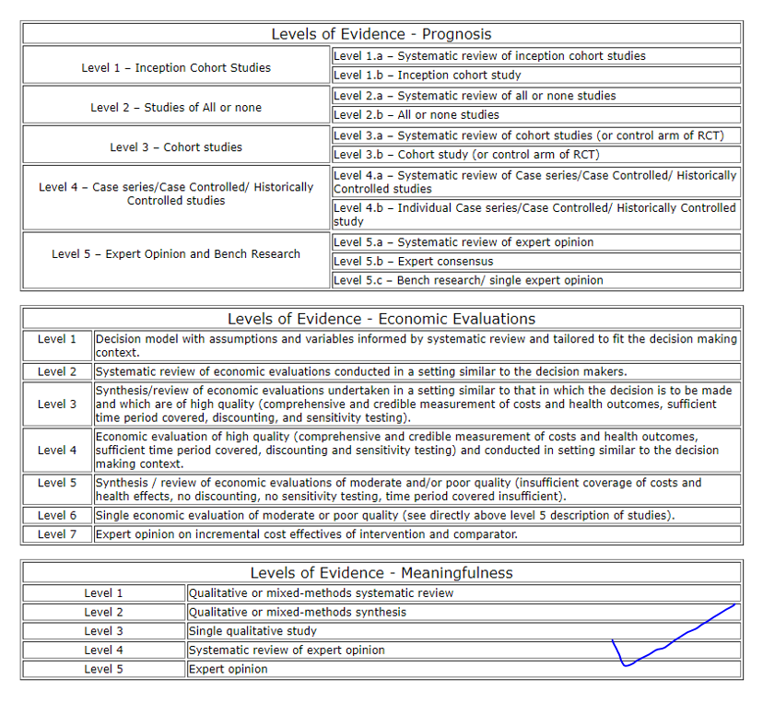

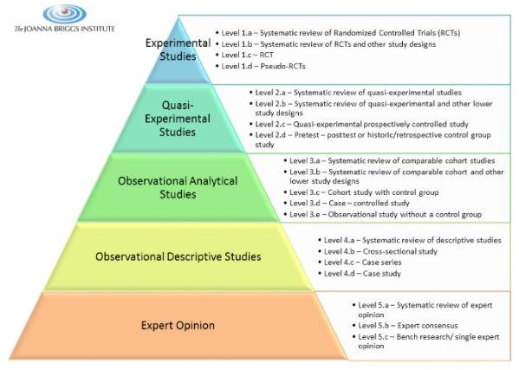
The Joanna Briggs institute levels of evidence for effectiveness
(The Joanna Briggs institute, 2014)

